ORDER ATTACHMENT – MAGENTO 2

USER GUIDE

Table Of Contents

Preface ......................................…………………………………..…......3

Installation..….………………………………………………………………………..4

option1.............................................................................4

option2……………................................................................5

Backend Example ……………………………………………………….....……...6

Extension Configuration…………………………………….…………………….6

Frontend Example……...………………………………………………….……....9

Preface :

* Magento 2 Order Attachment allows customers to upload files such as Images, PDF, word documents, excel documents and many other attachments while placing the orders.

* Magento 2 Order Attachment allows customers to Drag & drop
Functionality for upload documents.

* Magento 2 Order Attachment allows Admin can manage Attachments Size, Type, Limit of attachment per order

* Magento 2 Order Attachment allows Admin to send Attachments in email.

Installation:

There are two ways of installing extension in magento2.

1) Using COMMAND LINE.
2) Manually install extension.

Option 1: Magento 2 install extension using COMMAND LINE (Recommended).

Follow below steps to install extension from the command line.

Step 1: Download the extension and unzip it.

Step 2: Upload it to code directory in your magento installation’s app directory.
If code directory does not exists then create.

Step 3: Disable the cache under System → Cache Management.

Step 4: Enter the following at the command line:
php bin/magento setup:upgrade
php bin/magento setup:static-content:deploy

Step 5: Once you complete above steps log out and log in back to the admin
panel and switch to Stores → Configuration → Mageants → OrderAttachment.

The module will be displayed in the admin panel.

Option 2: Magento 2 install extension manually.

Step 1: Download the extension and unzip it.

Step 2: Upload it to code directory in your magento installation’s app directory.
If code directory does not exists then create.

Step 3: Disable the cache under System → Cache Management Edit
app/etc/config.php file and add one line code:
‘Mageants_OrderAttachment label’ → 1

Step 4: Disable the cache under System → Cache Management

Step 5: Once you complete above steps log out and log in back to the
admin panel and switch to Stores → Configuration → Mageants →
Mageants_OrderAttachment, the module will be displayed in the admin panel.

Backend example :

After Installation of Extension login to Magento admin panel to set
configuration of the extension.

Extension Configuration :

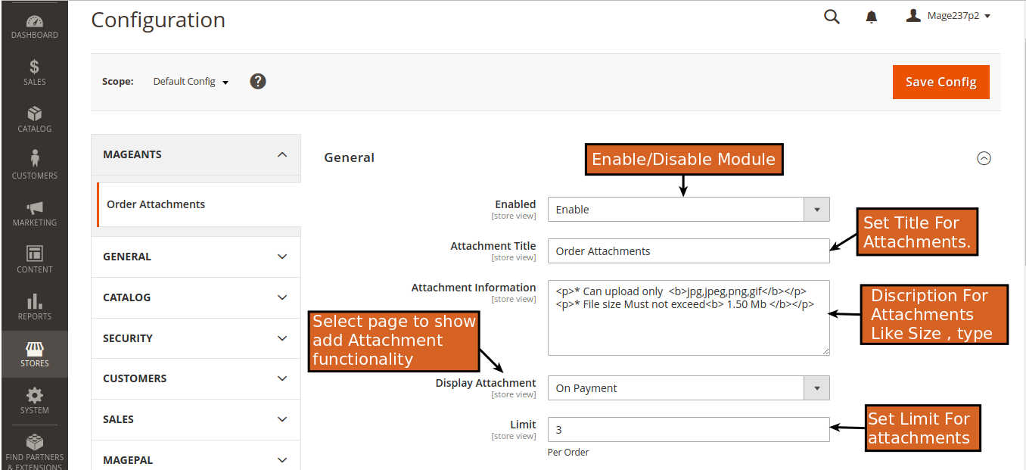

Attachment Title : Set Head Title For Attachment Sections.

Attachment Information : Set Information For Attachments
which is Display on Attachment Section.

Display Attachment : Select Display area for add
Attachments.

Limit : Set Attachment Limit Per Order.

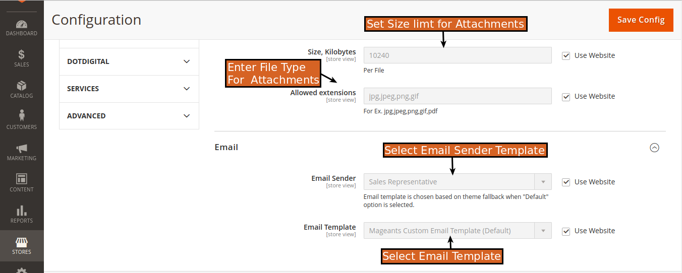

Size Kilobytes : Set Size For Attachments in Kilobytes (KB).

Allowed Extensions : In this field you can Validate the
format of document.

EMAIL :

Email Sender : Select Sender’s Email template for Mail
transportation.

Email Template : Select Custom Email template
for send E-mail.

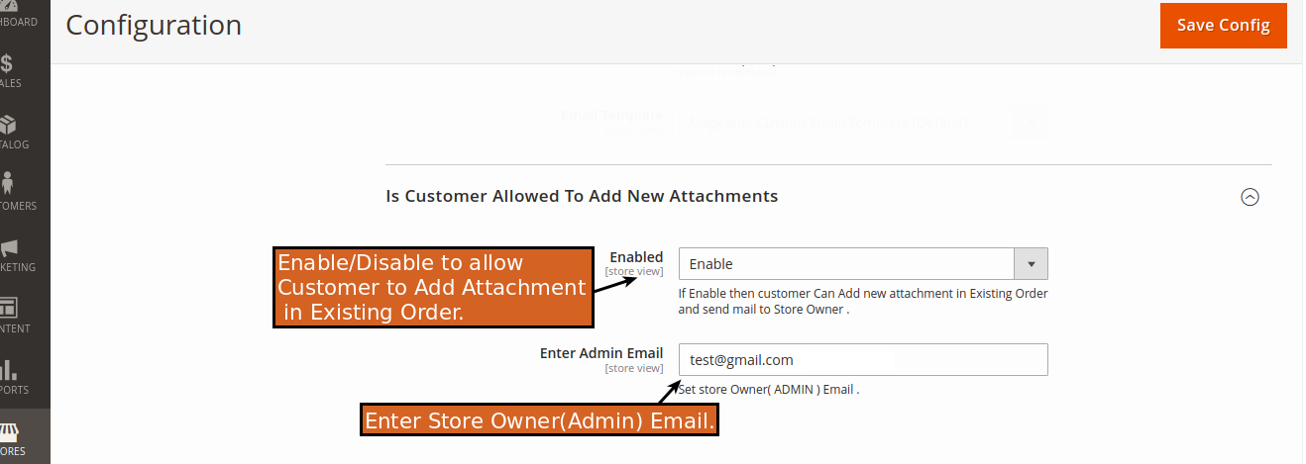

Is Customer Allowed to Add New Attachments :

Enable/Disable : If Admin Enable it then customer
can upload new Attachments in the
existing orders.

Admin Email : If customer allowed to upload new
attachments then customer can send
new attachments on Admin ( Store owner)
on Provided email.

=> SALES → Orders → View Order.

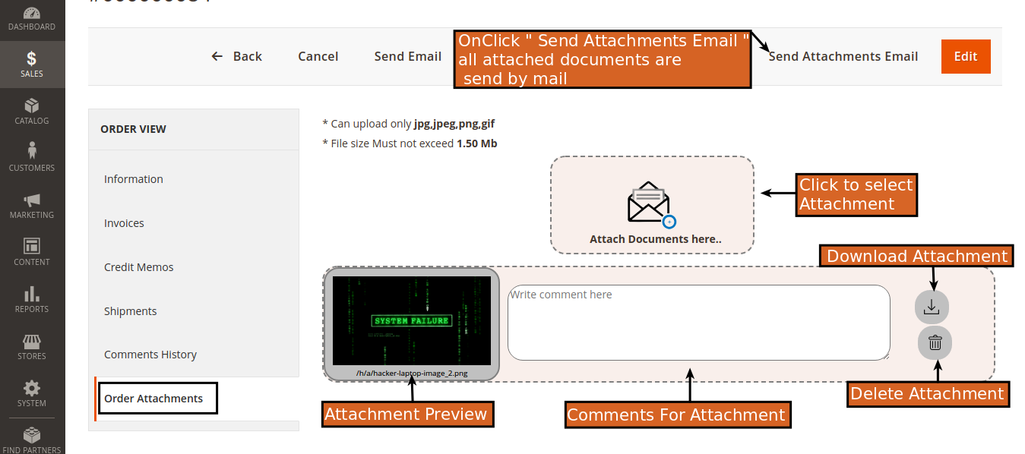

* On Sales Order View you get “Order Attachment“ tab
on left sidebar.

* In this menu Admin Can See All Attachments of Order.

* Here Admin can Upload new Attachments With comments.

* Admin can see Preview of Attached Documents.

* Admin can Download and Delete Previous
Attachments.

* There is “Send Attachment Email“ Button in Top
Top navigation bar, On-click on this All Of the Attachment
of particular order will send in E-mail.

Frontend example :

* Checkout Payment page :

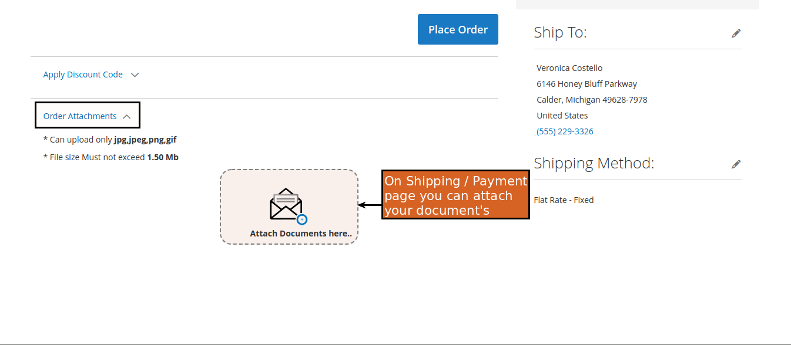

* In the Front-end Customer get Attachment selection
functionality in ( Shipment / Payment ) Page. Which was selected in “Display Attachment“
configuration.

* Customer Account ( My Orders Page ) :

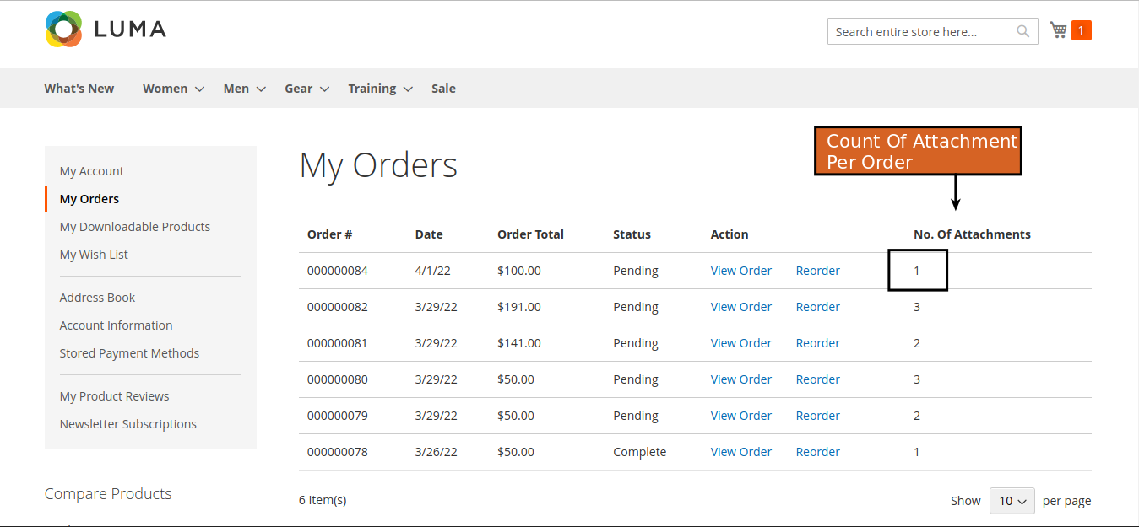

* On Customer Account → My Orders

→ there is Column which is showing the total count of
Attachments in order.

* Customer’s Order View Page :

( If Customer Allowed to Add New Attachments in Order. )

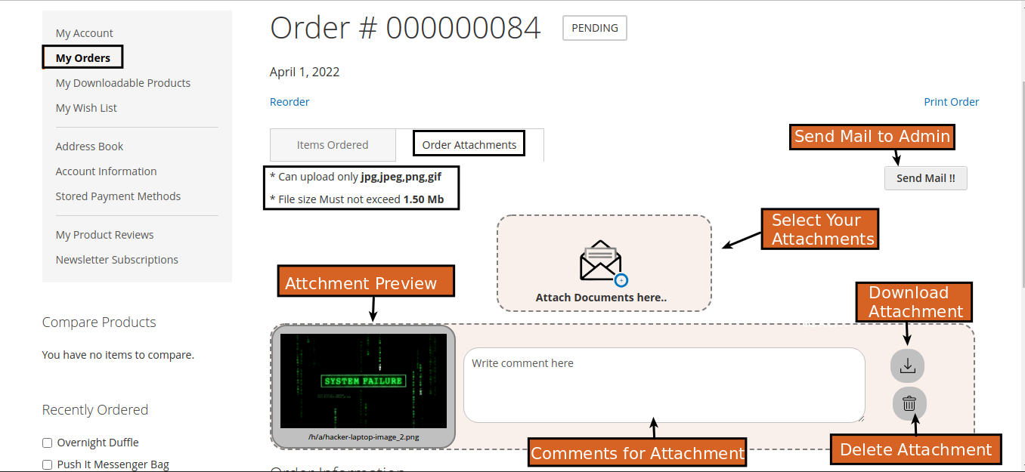

* On particular order view page Customer Can see Uploaded
Attachment.

* If ( Admin/Customer )upload Any New Attachment in previous Order of customer then it is displaying in that
order’s view page.

* Customer can also download and Delete the attachments.

* Customer can send Attachments threw the mail to Admin.

( If Customer not Allowed to Add New Attachments in Order. )

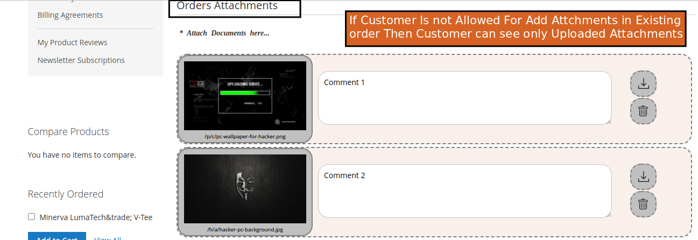

* Customer can Download and Delete the
attachment if Admin can not Allow to upload new Attachments in existing order.

Thank you!
if you have any questions or feature suggestions, please contact us at: https://www.mageants.com/contact-us

Your feedback is absolutely welcome!

